**Department of Computer Science and Engineering**

|  |  |
| --- | --- |
| **Course Code:CSE260** | **Credits: 1.5** |
| **Course Name: Digital Logic Design** | **Semester: Fall’18** |

**Lab 02  
Applications of Boolean algebra**

1. **Topic Overview:**

Boolean algebra is a useful and clever way to simplify digital circuits. Digital circuits are made up of **logic gates**. All logic gates have at least one input and exactly one output - all inputs of which are pins - and can only take two states.

Multiple logic gates can be connected with wires, forming a complex digital circuit. Outputs of logic gates can be connected to the inputs of other logic gates. When multiple logic gates work together, they can perform complex mathematical calculations.

After this lab, students will also gain the experience of working with practical logic circuits. Also, they will be able to simplify a complex function using **Boolean algebra** and can Implement **Boolean Function** using **logic gates**.

1. **Lesson Fit:**

Students must have the knowledge of fundamental logic gates and their input/output characteristics.

1. **Learning Outcome:**After this lecture, the students will be able to:
   1. Investigate the rules of Boolean algebra.
   2. Gain experience working with practical circuits
   3. Simplify a complex function using Boolean algebra
2. **Anticipated Challenges and Possible Solutions**
   1. Students will make mistakes while assembling the actual circuit.

Solutions:

Assembling circuits on your breadboard is a fast and easy process once you get used to it. To assemble your circuit first select the chips that you need, insert them in the breadboard, wire up the power and ground connections as described in the next section and next wire the logic elements according to the circuit connections that you obtained from the design process.

Before you insert a chip into the breadboard, make sure it is properly oriented and that when you press it down the pins of the chip actually enter the holes and do not bend underneath the chip package.

When wiring, be careful to hit the right hole needed in the connection, because this is one of the most common mistakes found to cause an error in your experiment.

1. **Acceptance and Evaluation**

Students will show their progress as they complete each step of the problem. They will be marked according to their lab performance. Students have to show the outputs and proper connections for the given problem. Otherwise, full marks will not be given.

1. **Activity Detail**

**Hour: 1  
Discussion:**In order to assemble the lab experiments, every student should use his/her own

Breadboard (similar to the one shown in Figure 1). Firstly, two rows in the both sides will be used for power supply. (+ will be +5V and – will be ground). Next, the breadboard has a total 10[5(a-e) and 5(f-j)] rows consisting of 30 holes e.g. columns for each row. All the columns are vertically interconnected.

For example:

a18= b18 = c18= d18= e18 (all have the same input)

a18 ≠ a17

The rows and columns are used to hold chips and wires, and interconnect them as shown in Figures 1.

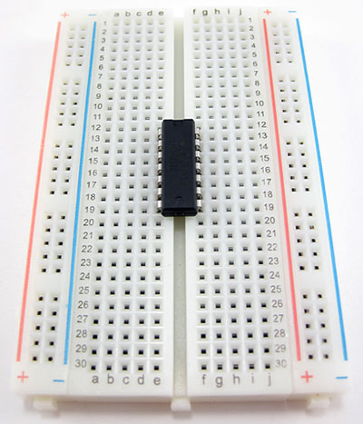

Figure: 1

Later in the Laboratory, students need to make a truth table for the given problem that will help them to check and understand the circuit constructed from the breadboard.

**Problem Task:**

* Construct the circuit showed in the Figure 2 using logic gates.
* Closely monitor the final output  
  1. **Hour: 2**

**Discussion:**

We will have a discussion about the output pattern and the simplified function for the given task.

We may use some Laws of Boolean Algebra. (Table 1-1)

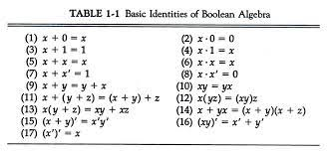  
  
**Problem Task:**

Construct the simplified function for the given task. Then, ask them to construct the circuit again and match the result.

* 1. **Hour: 3**

**Discussion:** Check their progress in implementation.   
  
**Problem Task:**Construct the Circuit again if necessary.

1. **Home tasks:**

As a part of their home tasks students need to submit a lab report covering the followings

1. Name of the Experiment
2. Objective
3. Required Components and Equipment
4. Experimental Setup (You must draw the IC configurations)
5. Results (Truth Table) and Discussions .The discussions part must include the answers of the following questions:
   * What is the Boolean Equation for the output?
   * Simplify the Boolean equation.
   * The circuit’s function is identical to a single gate. Write down the name of that gate.

**Lab02 :Activity List**

**Required Components and Equipment**

1. AT-700 Portable Analog/Digital Laboratory
2. 7400×1

**Diagram of Circuit:**

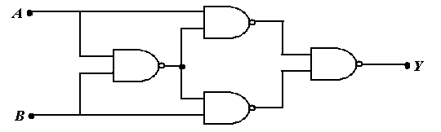

**Figure 2**

**Procedure:**

* Construct the Circuit of Figure 2, on the breadboard of AT-700.
* Remember each IC’s pin 14 connected to “+5V” position of DC Power Supply of AT-700, and pin 7 connected to “GND” position.
* Connect the inputs to Data switches and outputs to any position of LED Display.
* Find out the outputs for all possible combinations of input states.
* Write down the input-output in tabular form.